**Experiment No:02**

**Aim:To design Flutter UI by including common widgets.**

**Theory:**

**Common Widgets in Flutter**

Flutter provides a wide range of widgets that developers can use to build rich and interactive user interfaces. These widgets serve various purposes, from displaying text and images to handling user input and managing layouts. Here's a brief theory on some of the most commonly used widgets in Flutter:

1. **Text Widgets:**
   1. Text: Displays a string of text with customizable styles such as font size, color, and alignment.
   2. RichText: Allows for more complex text formatting, including inline styles and multiple text spans.
2. **Input Widgets:**
   1. TextField: Allows users to input text with options for customization and validation.
   2. TextFormField: A specialized version of TextField that integrates with forms and provides validation and error handling.
3. **Button Widgets:**
   1. ElevatedButton: Represents a button with a raised appearance, typically used for primary actions.
   2. TextButton: Represents a button with text only, suitable for secondary actions.
   3. IconButton: Represents a button with an icon, often used for actions like navigation or settings.
   4. FloatingActionButton: Represents a circular button, commonly used for prominent actions.
4. **Selection Widgets:**
   1. Checkbox: Represents a checkbox that allows users to toggle a binary state.
   2. Radio: Represents a radio button that allows users to select one option from multiple choices.
   3. Switch: Represents an on/off switch toggle.
   4. Slider: Represents a slider control for selecting a value from a range.
5. **Layout Widgets:**
   1. Row: Arranges children widgets horizontally in a row.
   2. Column: Arranges children widgets vertically in a column.
   3. Stack: Overlays widgets on top of each other, allowing for complex UI compositions.
   4. Container: A versatile widget that allows customization of its child's position, size, and appearance.
6. **Scrolling Widgets:**
   1. ListView: Displays a scrollable list of widgets, either vertically or horizontally.
   2. GridView: Displays a grid of widgets in rows and columns, with options for scrolling and item customization.
   3. SingleChildScrollView: A scrollable container that allows its child to be scrolled in one direction.
7. **Material Design Widgets:**
   1. AppBar: Represents the app bar at the top of the screen, typically used for navigation and branding.
   2. Scaffold: Implements the basic material design visual layout structure, including app bars, drawers, and bottom navigation.
   3. Card: Represents a material design card, often used to display related information or content.
8. **Interaction Widgets:**
   1. GestureDetector: Detects various gestures such as taps, swipes, and drags on its child widget.
   2. InkWell: A material design inkwell that responds to touches with a splash effect, commonly used for touch feedback.

**Code:**

import 'package:flutter/material.dart';

void main() {

runApp(MyApp());

}

class MyApp extends StatelessWidget {

@override

Widget build(BuildContext context) {

return MaterialApp(

title: 'Flutter Exp-2',

theme: ThemeData(

primaryColor: Colors.teal, // Change primary color

colorScheme: ColorScheme.fromSwatch(

primarySwatch: Colors.teal, // Change primary swatch

).copyWith(secondary: Colors.deepOrange), // Change secondary color

),

home: MyHomePage(),

);

}

}

class MyHomePage extends StatelessWidget {

@override

Widget build(BuildContext context) {

return Scaffold(

appBar: AppBar(

title: Text('Flutter Expt-2'),

),

body: Center(

child: Column(

mainAxisAlignment: MainAxisAlignment.center,

children: <Widget>[

Text(

'Welcome to Flutter Exp-2',

style: TextStyle(

fontSize: 24,

fontWeight: FontWeight.bold,

color: Colors.blue, // Change text color

),

),

SizedBox(height: 20),

ElevatedButton(

onPressed: () {

print('Button clicked!');

},

style: ElevatedButton.styleFrom(

primary: Colors.deepOrange, // Change button color

),

child: Text('Click Me'),

),

SizedBox(height: 20),

TextField(

decoration: InputDecoration(

hintText: 'Enter your name',

labelText: 'Name',

border: OutlineInputBorder(),

focusedBorder: OutlineInputBorder(

borderSide: BorderSide(color: Colors.deepOrange), // Change border color

),

),

),

SizedBox(height: 20),

CheckboxListTile(

title: Text('I agree to the terms and conditions', style: TextStyle(color: Colors.teal)), // Change text color

value: false,

onChanged: (value) {

print('Checkbox value changed to: $value');

},

controlAffinity: ListTileControlAffinity.trailing,

activeColor: Colors.deepOrange, // Change active color

),

SizedBox(height: 20),

DropdownButton<String>(

value: 'Option 1',

onChanged: (value) {

print('Dropdown value changed to: $value');

},

items: <String>['Option 1', 'Option 2', 'Option 3']

.map<DropdownMenuItem<String>>((String value) {

return DropdownMenuItem<String>(

value: value,

child: Text(value),

);

}).toList(),

underline: Container( // Remove dropdown underline

height: 0,

),

icon: Icon(Icons.arrow_drop_down, color: Colors.deepOrange), // Change dropdown icon color

elevation: 4,

),

],

),

),

);

}

}

**Output:**

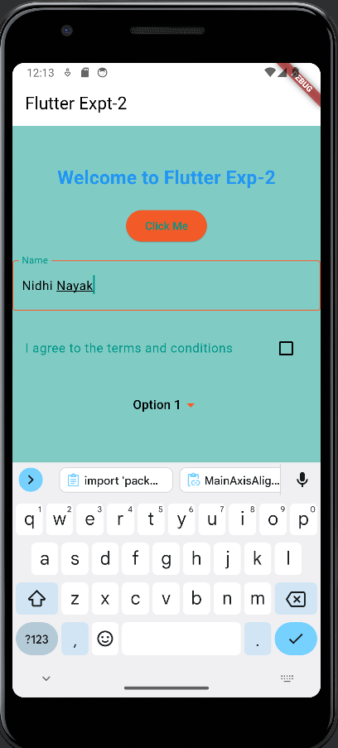



**Conclusion:**

I have successfully studied and used different Common Widgets used in Flutter UI such as Column Widget, Scaffold,Text,SizedBox etc.